ECOLOGY UNIT KEYSTONE ASSESSMENT

Student Review Packet

1. Match the living parts of an ecosystem with the examples below. Write the correct letter on the line to the right of each example.

A = producer B = primary consumer C = secondary consumer D = decomposer

A tree ___A____ | A hawk eating a lizard ____C___ | A squirrel eating a nut ___B____
A grasshopper eating grass ____B___ | Bacteria changing dead plants to nitrates ___D____ | A human eating lettuce __B_____
A frog eating a grasshopper ___C____ | Bracket fungi decaying a stump ____D___

2. Complete the following sentences by writing the correct word or words from the word bank in the space provided.

Word Bank: autotrophs biome biotic ecology ecosystem

food chain heterotroph nitrates

A(n) _____ is an area characterized by certain living things and a certain climate. | ____BIOME_______
A(n) _____ is a pathway of food through an ecosystem. | __FOOD CHAIN___
_____ is the study of how the living and nonliving things in an ecosystem affect each other. | _____ECOLOGY___
The living parts of an ecosystem are the _____ parts. | ____BIOTIC______
Plants get needed nitrogen mostly from substances called _____. | _____NITRATES___
_____ are living things that make food. | _AUTOTROPHS___
A(n) _____ is a combination of the living and nonliving things in an area. | __ECOSYSTEM__
Living things that get their food by eating other living things are _____. | _HETEROTROPHS_

3. Each of the following statements describes a stage in land succession. Number the statements in the order they would occur in land succession.

___5___ A forest is present.

___4___ Bushes and small trees are present.

___1___ Bare soil is present.

___3___ First primary consumers appear.

___2___Weeds begin to appear.

4. Each of the following statements describes an example of succession. Identify if each is an example of primary succession or secondary succession.

___Primary____ Lichens appear on rocks, where life has never before existed.

Secondary_____ Growth in an agricultural field no longer farmed.

__ Primary _____ Land exposed by a retreating glacier.

Secondary ___ Growth in Yellowstone National Park after a large forest fire.

__ Primary __ A lake begins to fill with sediment.

5. Choose the type of symbiosis from the word bank that best matches each statement below.

Word Bank: parasitism mutualism commensalism

Protists inside termites digest the wood the termites eat. _____Mutualism________

A mosquito “bites” you. _____Parasitism_________

Protists live inside a mosquito but do not harm the mosquito. _____commensalism_____

Bacteria in a lump on the clover root change nitrogen into a form used by clover and get a place to live. ______Mutualism________

A fungus uses some of a tree’s nutrients. _____parasitism_____

An alga and a fungus live together. Both benefit each other. _____mutualism____

A tick gets food from the blood it removes from a dog. _____parasitism_____

Orchids grow on trees to capture more sunlight. The tree is not harmed._____commensalism___

6. Use the word bank below to fill in the blanks for the following environmental issues statements.

Word Bank: Acid Precipitation Deforestation Endangered Species
Global Warming Greenhouse Gases Ozone Depletion Pfiesteria

As a result of ____Ozone Depletion_________, more ultraviolet radiation will reach the earth’s surface.

Continued development and habitat destruction is increasing the number of _______Endangered Species______.

Carbon dioxide and methane are examples of ___Greenhouse gases_________.

____Pfiesteria_______ is a microscopic algae often thought to be the cause of lesions (sores) on fish throughout coastal regions.

An increase in the release of carbon dioxide and methane into the atmosphere may result in an increase in the Earth’s average surface temperature, called _____Global Warming______.

Rain, hail, sleet, or snow that has a pH lower than normal may be considered an example of ____Acid Precipitation________.

As a result of ______Deforestation_____, there will be an increase in the amount of surface runoff and erosion from the land.

7. CARBON CYCLE
A
B
C
E
D

- Match the following components of the carbon cycle to the appropriate letter in the diagram.

carbon dioxide in the atmosphere ____B_____ decomposition ____C_____

combustion (burning of fossil fuels) ____E____ photosynthesis ____A_____

cellular respiration ____D____

- Place a plus sign (+) next to the component of the carbon cycle if it adds carbon dioxide to the atmosphere and minus sign (-) next to the component if it removes carbon dioxide from the atmosphere.

decomposition _____+_____ combustion _____+____

photosynthesis _____-____ cellular respiration _____+____

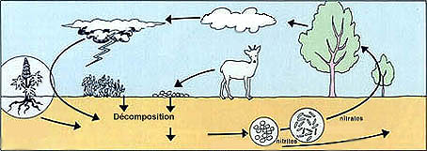
8. NITROGEN CYCLE
A
B
C
D
E
F

- Match the following components of the nitrogen cycle to the appropriate letter in the diagram.

nitrogen gas in the atmosphere _____A,B____

absorption of nitrates by plants _____D____

nitrogen fixation by lightning and soil bacteria _____C_____

denitrification ____ B_____

ammonification (nitrogen fixed as ammonium) _____E_____

bacteria convert ammonia to nitrates _____F_____

9. Water Cycle
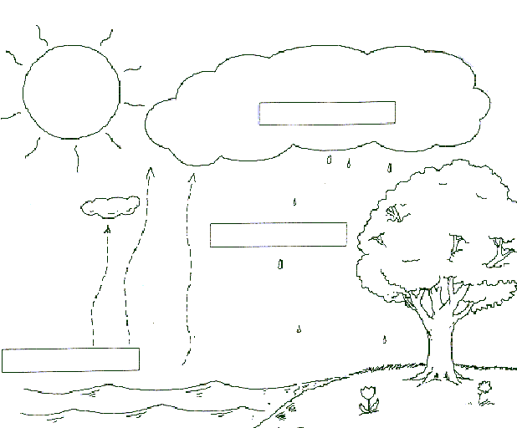
A
B
C
D
E
F
G

- Match the following components of the water cycle to the appropriate letter in the diagram.

precipitation _____B______ condensation ___A______

evaporation ____C______ transpiration ____D______

surface water ____G_____ runoff from the surface ____E______

seepage and infiltration to groundwater ___F______

10. Complete the table below using information from the map and your textbook.

Biome | Location on map | Temperature Range | Average precipitation per year | Some common plants  and animals
TROPICAL FOREST | F | 27°C | 200 – 400 cm/year | Many multilayered trees, vines, ground layer plants, many birds, amphibians, reptiles
DESERT | E | 20°C to 49° C | Less than 20 cm/ year | Cactus. Deep rooted shrubs, pine trees snakes, owls, coyotes
TEMPERATE DECIDUOUS FOREST | B | -30 °C to +30° C | 100 – 200 cm /year | Broadleaf deciduous trees, squirrels, deer, bear,
GRASSLAND | C | 0° to 25°C | 25 – 100 cm/ year | Tall grasses, few trees, large grazers, bison, deer,
TAIGA | A | -25°C to 25°C | 0 – 100 cm /year | Conifer trees, moose, deer , elk, wolves, bear, hares
TUNDRA | D | -22°C - 6°C | 0 – 25 cm /year | Migratory birds, short plants and trees, lemmings, arctic fox, snowy owl.
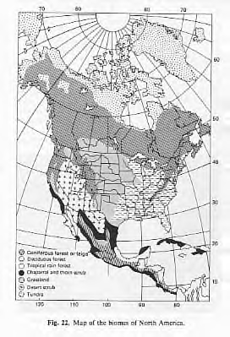
A
B
C

D
E

F

BIOME MAP OF NORTH AMERICA

11. Complete the energy pyramid using the organisms in the food web below. Then, use the energy pyramid to answer the questions that follow.
rat snake
small lizard
hawk

oriole
bird
fungus
grasshopper

plant

Hawk,
Rat snake

Small lizard, oriole bird

grasshopper

plant

How does the energy amount change among the different trophic levels?
Only about 10 % makes it through from one level to the next .

In what form(s) is energy lost from the pyramid?
________________heat_________________________

How does the biomass amount change among the different trophic levels?
________the biomass decreases quickly as you go up t through the levels________________________

Use the reading passage and the diagram below to answer Numbers 12 and 13.

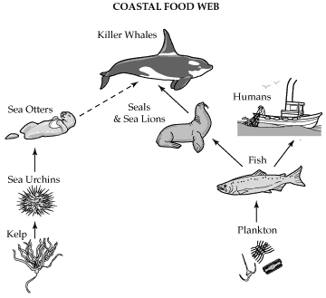

WHY ARE SEA OTTER

POPULATIONS DECLINING?

The number of sea otters living along Alaska's Aleutian Islands has fallen to 10% of what it was a decade ago. The investigation into what is happening to this population is revealing a great deal of information about the complex nature of food webs. It is also showing how fragile the links in a food web can be.

The immediate cause of the sea otters' decline seems to be predation by killer whales, which are turning to sea otters as a food source. James Estes, a University of California marine ecologist, first witnessed a killer whale eating a sea otter in 1991. Since then, a dozen such attacks have been reported. Estes suspected that these attacks were ultimately caused by disruption of the marine food web.

Many fish populations have declined dramatically, and species that marine mammals feed upon have been hit especially hard. The cause of this decline is not entirely understood, but it is thought to be due to a combination of overfishing, warming ocean temperatures, and other factors. Killer whales normally eat sea lions and harbor seals, but with local fish populations so low, these seal populations have rapidly declined. This has caused killer whales to resort to a new food source, the smaller and less nutritious sea otter.

This decline in the sea otter population has disrupted much of the coastal ecosystem along the Aleutian Islands. Sea otters prey upon sea urchins, which, in turn, feed upon kelp, a type of large seaweed that is abundant in many coastal ecosystems. Kelp beds provide protection for many species of fish and other small animals, and are an important basis of the coastal food web. In Estes' view, these changes are "an ecological chain reaction," with events that occur far out at sea causing massive changes to the coastal ecosystem

12. Which of these statements best summarizes James Estes' hypothesis about the decline of sea otter populations?

A The killer whales are eating more seals and sea lions.
B Kelp beds are an important basis of the coastal food web.
C The sea otter population has fallen to 10% of what it was a decade ago.
D Killer whale attacks on sea otters are caused by a disruption of marine food webs.

13. Which of these follow-up studies would best evaluate James Estes' hypothesis about the decline of sea otter populations?

A contrast the nutritional content of seal meat and sea otter meat
B count the total population of sea urchins living off the Aleutian Islands
C survey the number of attacks on sea otters by killer whales in the Aleutian Islands over the next ten years
D survey the number of attacks on sea otters by killer whales in an area where both sea otters and seals are abundant

Use the diagram of the ocean food web below to answer Numbers 20 and 21.
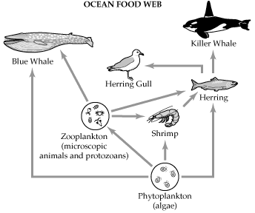
OCEAN FOOD WEB

14. Which of these organisms is not an omnivore?
A herring
B shrimp
C blue whale
D killer whale

15. Improvements in fishing techniques have led to an increase in the amount of herring harvested in recent decades. What would be a direct effect of increased harvests of herring?

A The blue whale population would decrease.
B The herring gull population would increase.
C The killer whale population would increase.
D The shrimp population would increase.

The energy pyramid below shows the flow of energy through the organisms in a Maryland river.
Use the diagram to answer Numbers 16 through 17.

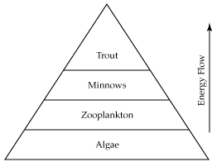
ENERGY PYRAMID SHOWING FLOW OF ENERGY

16. Which of these organisms are the producers in the river ecosystem?

A algae
B minnows
C trout
D zooplankton

17. If the trout population were over fished, which population of organisms would most likely increase as a direct result?

A algae
B minnows
C trout
D zooplankton

18. Which level of the pyramid represents the largest percentage of available energy?

A algae
B minnows
C trout
D zooplankton

19. According to the pyramid, what is the niche of the trout?

A autotroph
B carnivore
C herbivore
D primary consumer

